IEEE 1532
IEEE Standard for In System Configuration

- 1532 overview

IEEE 1532 standard was introduced in 2001. Its main precursor was idea of In-System Programming first introduced by Lattice Semiconductors [Isy]. This standard was designed to boost in-system programming (here called In-System Configuration) of 1149.1-compliant PLD devices regardless of their actual vendor. As a result, PLD devices may be programmed after being mounted on a board and several operations required to program devices could be merged into one. As described [Ain], the main mission of the working group of IEEE 1532 was to “define, document and promote the use of a standardized process and methodology for implementing programming capabilities within programmable integrated circuits, utilizing and compatible with IEEE 1149.1 communication protocol. This standard would allow the programming of one or more compliant devices concurrently, while mounted on a board or embedded in a system”. Moreover, IEEE 1532 defines a data format for data programmed into PLD devices. Nowadays, it is a common standard supported by various boundary scan chain IDEs, such as ScanWorks or ispLattice, as well as many chip vendors, i.e. Altera who was the first supplier of chips compatible with the standard [Alt].

- 1532 state machine

The main feature of the 1532 standard is an introduction of various system modal states. These are:
- Unprogrammed mode;
- ISC accessed mode;
- ISC complete mode;
- Operational mode.

Full state machine is shown on Fig.XX.

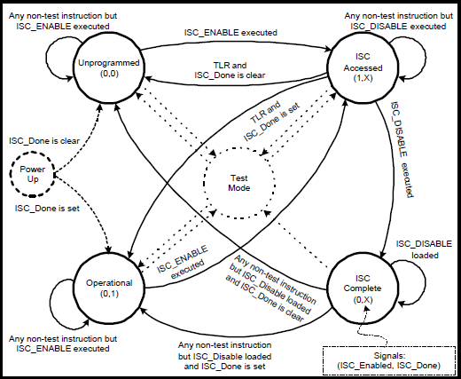

Fig.XX IEEE 1532 state machine. Source: [Sta]

Test mode can be accessed from every corner state if a test instruction is loaded and vice versa- each mode can be accessed from a test mode if appropriate instrucion is loaded as well. Optional status and device security mechanisms are also being introduced. IEEE 1532 may be introduced as an upgrade to IEEE 1149.1 standard – it uses the same 5-pin configuration and TAP state machine as 1149.1. However, new control signals are added: ISC_Enabled and ISC_Done. ISC_Enabled shows whether the device is ready to be programmed. ISC_Done shows whether write operation finished or not.

2. Data registers in 1532 standard

Mandatory registers introduced in 1532 are [Tut]:

- ISC_Default – passive data register that may act as a Bypass register in 1532;
- ISC_Config – program configuration register used to pass execution parameters or read a current status word;
- ISC_PData – program address/data register;
- ISC_Rdata – readback data register;
- ISC_Status – optional 2-bits register used to indicate status of the current instruction or programming error.

There are also various optional registers (ref.[Tut], p.45, Fig.39), such as ISC_Sector used to identify programming sectors, ISC_Info containing current state and factory information. Different optional features of 1532 are compliance enable pins or fixed system pins.

3. Instruction registers in 1532 standard

Apart from a set of standard IEEE 1149.1 instructions which are EXTEST, BYPASS, PRELOAD, IDCODE, USERCODE and SAMPLE, 1532 introduces instruction necessary for in-system configurations. These are:

- ISC_Enable – when set, enables programmingenvironment.
- ISC_Disable – when set, disables programming environment and resets ISC_Enable signal.
- ISC_Program – accesses program addresses and data registers,
- ISC_Noop – places device into a passive state. Used for programming multiple devices in parallel.

Optional instructions are:

- ISC_Read – read memory content;
- ISC_Erase – erase memory content;
- ISC_Discharge – Load data to discharge high-voltage charge pumps set up when programming;
- ISC_Program_Usercode – set 32-bit long user identification code.

There are also special instructions regarding program control, security and address and data access that specify the way data are being loaded or whether address is incremented after each read or write operation.

4. Facilities in programming 1532-compliant devices

Various formats and languages may be used to program PLD devices [Isy]:
- Serial Vector Format files acting as an assembly code of a boundary scan and most basic programming file format that is supported by most vendors. It doesn't allow control flow – the only possibility is the straight-line execution of given commands;
- STAPL JEDEC Standard Test & Programming Language based on JAM made by Altera that includes programming data and basic programming algorithm. Used by embedded system programmers;
- 1532 ISC (In System Configuration) data file defined in 1532 standard that includes program data to be matched with BSDL flows. Requires separate data and algorithm using extension to 1149.1 BSDL files and new ISC data format. Control flow is limited

Naturally, appropriate BSDL files are also upgraded to be 1532-compliant.. This standard introduces possibility to implement so-called programming flows, procedures and actions:

- Flow is a logical configuration of ISC instructions performing a basic programming function. It also specifies how the process obtains programming data (i.e. hard-coded data, address data or R/W data);
- Procedure is an allowed sequence of flows used to complete a specific operation;
- Action is an allowed sequence of procedures, i.e. a complete programming cycle.

Example of a Flow, Procedure and Action is shown on Fig.XX.

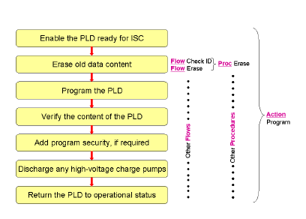

Fig.XX Ideas of Flow, Procedure and Action

- References

[Isy] Neil G. Jacobson, The In-system configuration handbook:A designer's guide to ISC, 2004, Springer;
[Alt] http://www.altera.com/products/devices/max7k/features/m7k-ieee1532.html
[Ain] Asset Intertech, IEEE 1532 CONCURRENT IN-SYSTEM CONFIGURATION
[Sta] IEEE std P1532, A New Standard for 1149.1-based In System Configuration, chair: Neil G. Jacobson, 23.9.1999
[Tut] IEEE 1149 JTAG and Boundary Scan Tutorial, ScanWorks;

